**WEEK 11 ASSIGNMENT**

**Steps**

**1.Host a Ubuntu Virtual Machine using Oracle VM Virtual Box.**

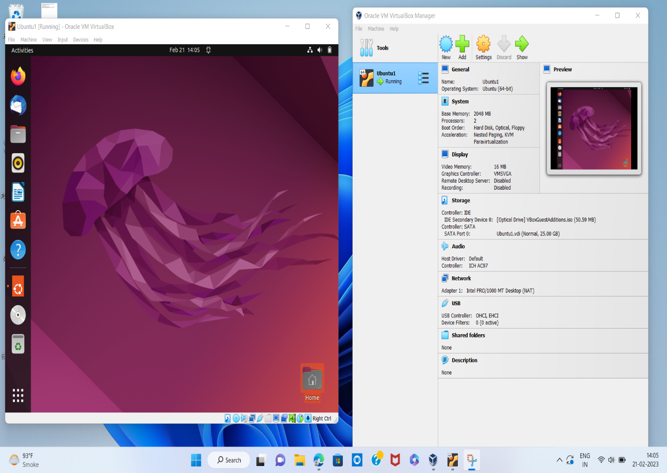

**2.Set up Visual Studio code on Ubuntu VM.**

Download a file “code-1.75.1-1675893397_amd64.deb”

Command : sudo dpkg -i code-1.75.1-1675893397_amd64.deb

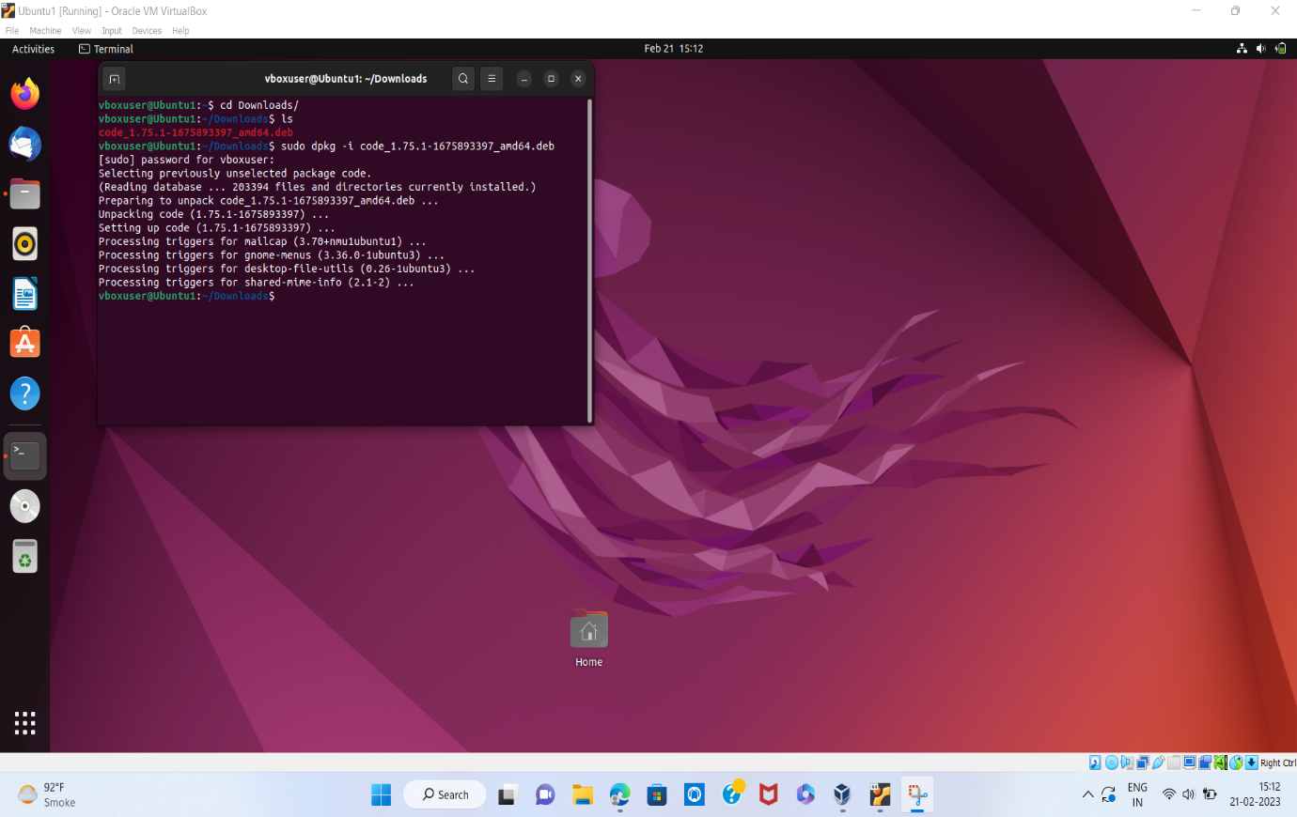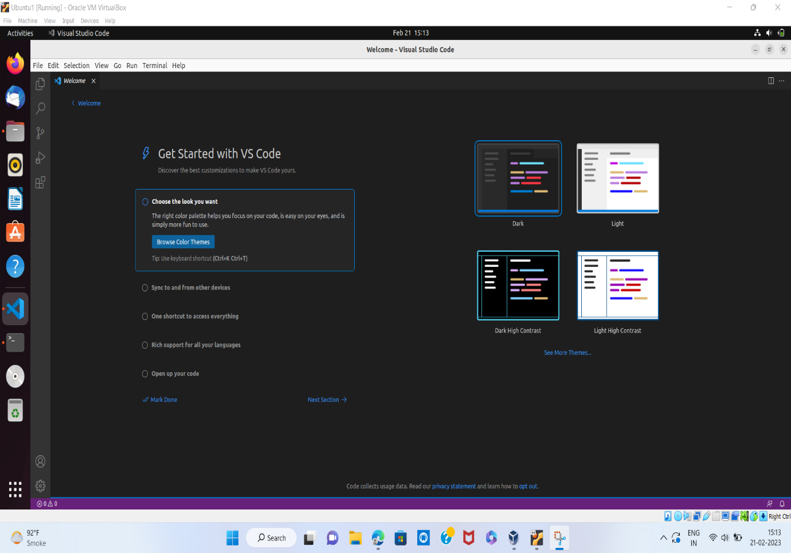

**3.Set up Python.**

Command 1: sudo apt update

Command 2: sudo apt install software-properties-common

Command 3: sudo add-apt-repository ppa:deadsnakes/ppa

Command 4: sudo apt install python3.9

●Verification of the installation was successful.

Command: python3.9 –version

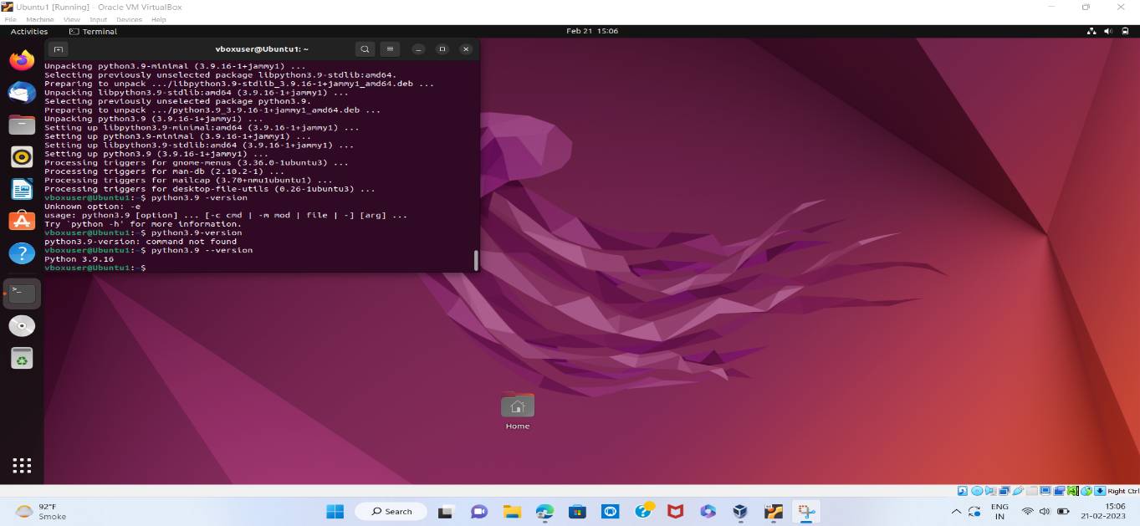

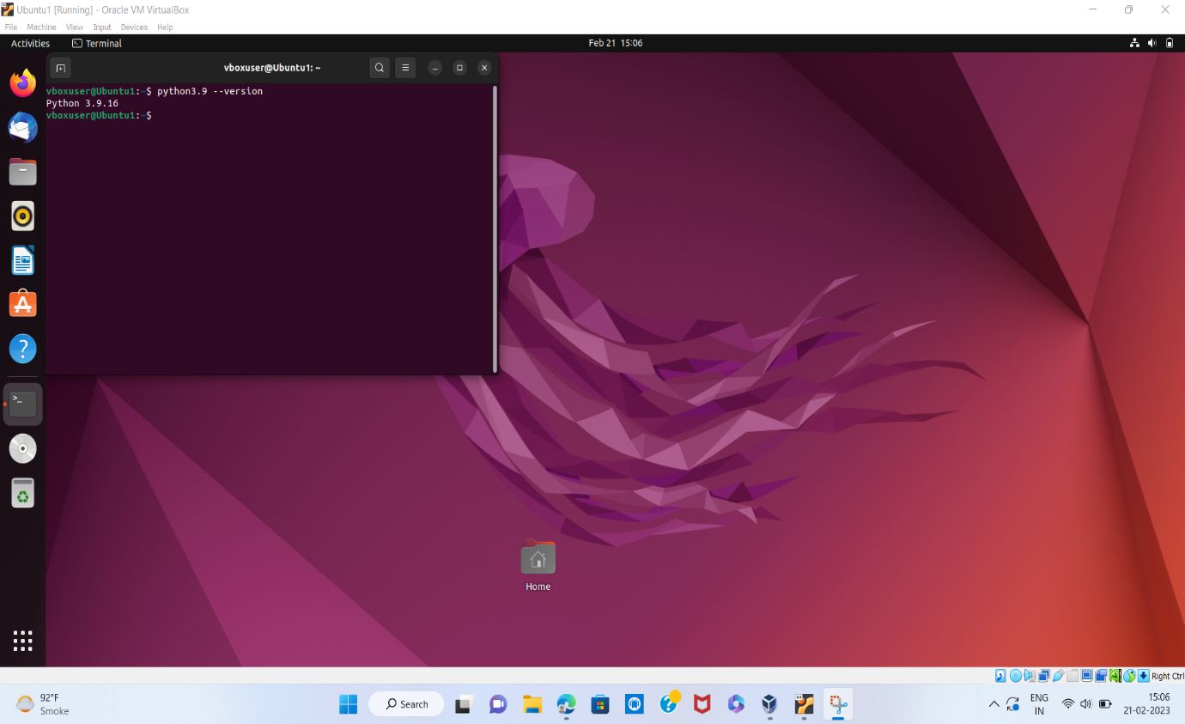

**4.Clone this Github repository**

**https://github.com/Vikas098766/Microservices.git**

Install git and then clone the specified repository

Command : git clone https://github.com/Vikas098766/Microservices.git

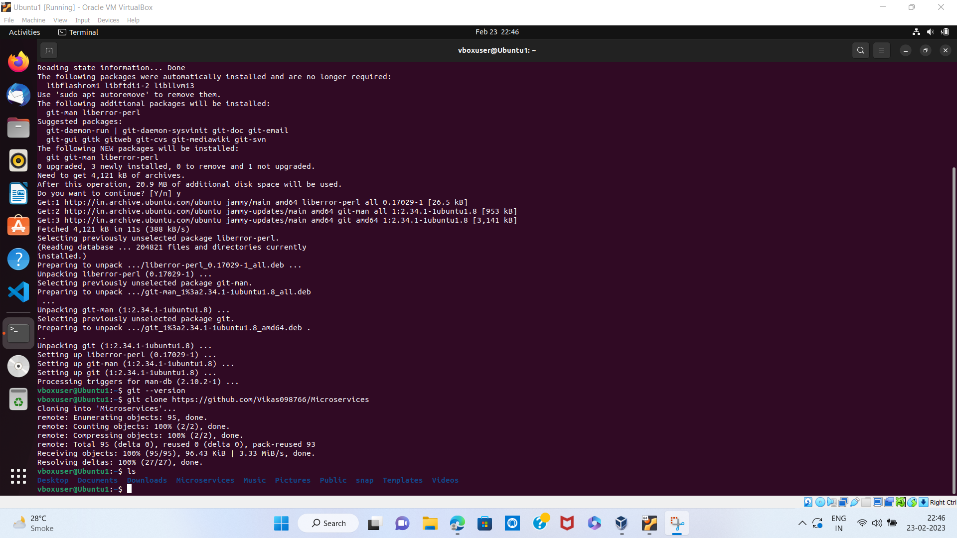

**5.Create a Virtual Environment.**

Command : python3 -m venv myenv

Command: source venv/bin/activate

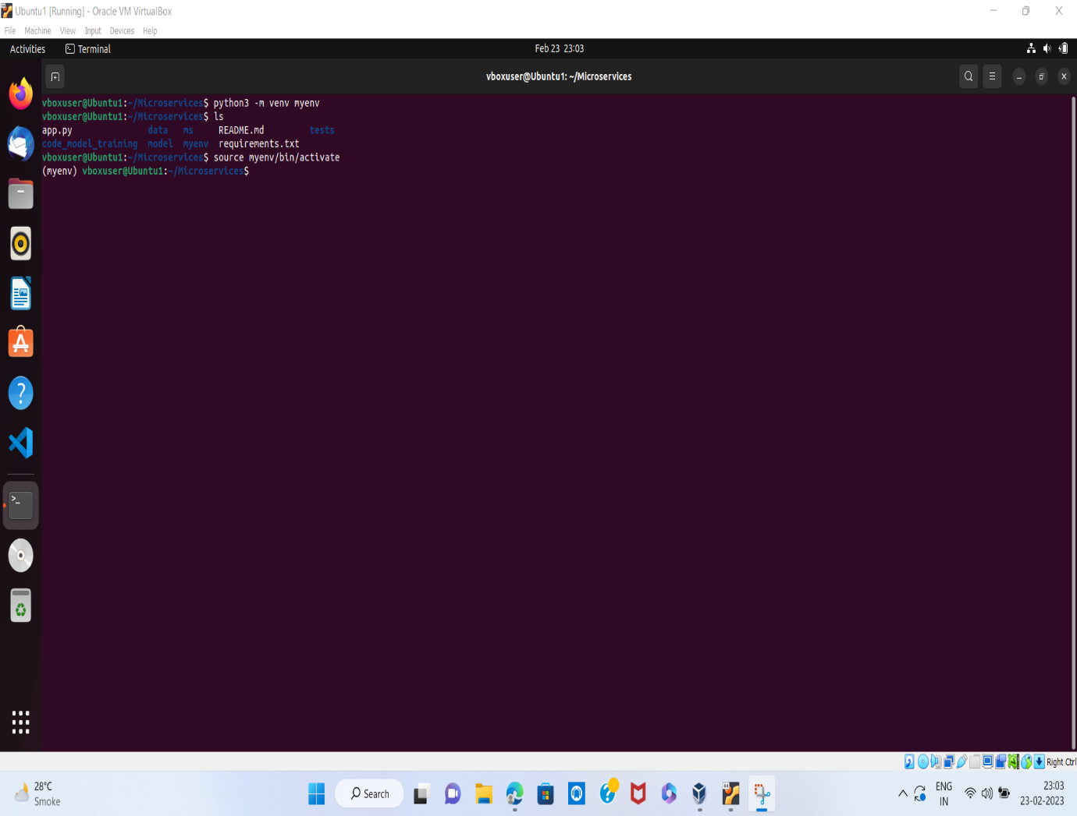

**6.Install the dependencies from requirements.txt file.**

Command : pip install -r requirements.txt

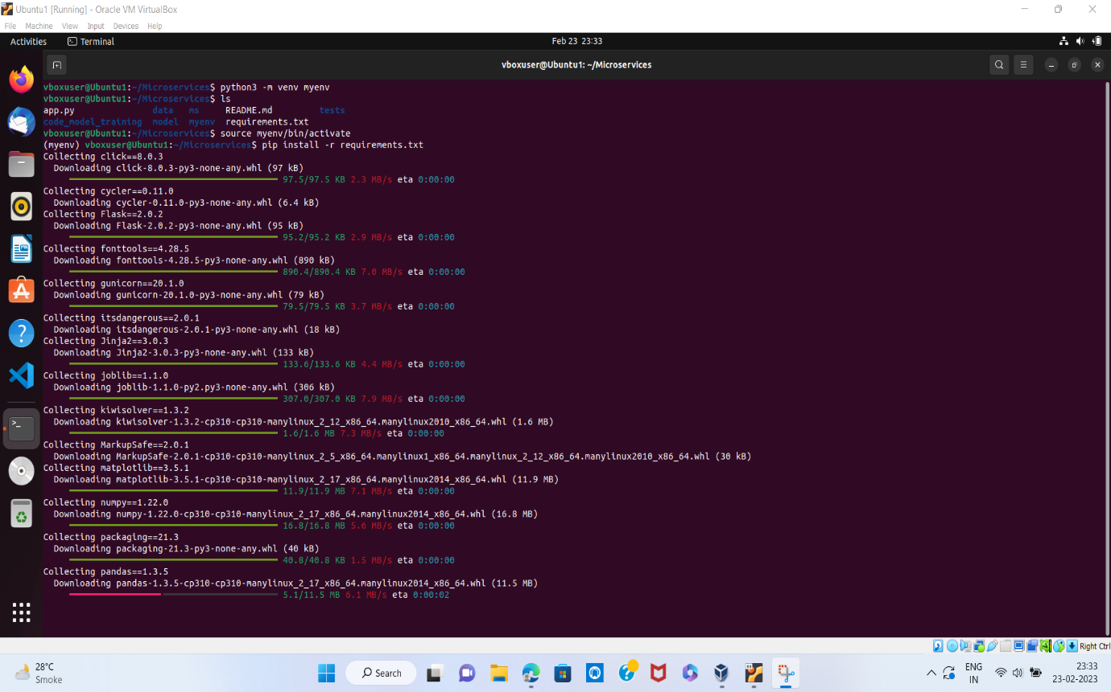

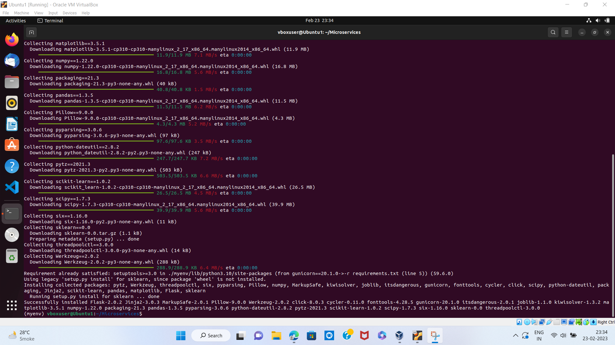

**7.Train and save the model.**

Command : python code_model_training/train.py

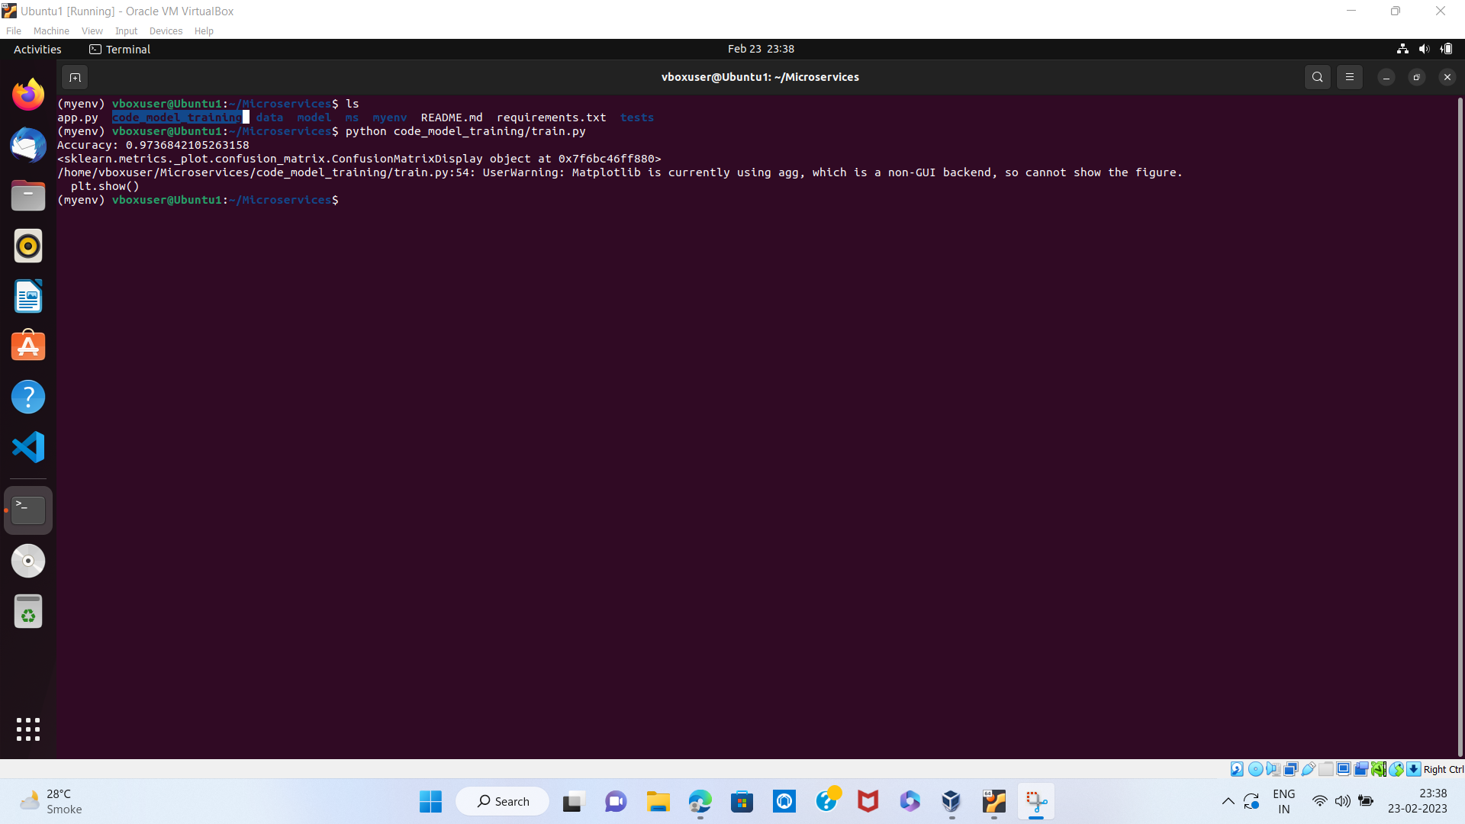

**8.Test the Flask web application.**

Command : flask run -p 5000

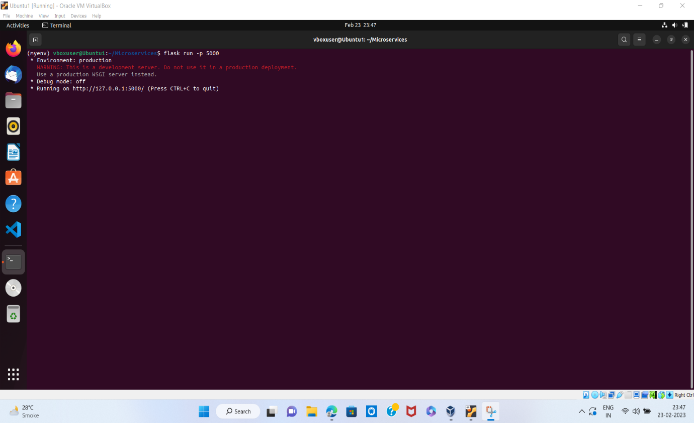

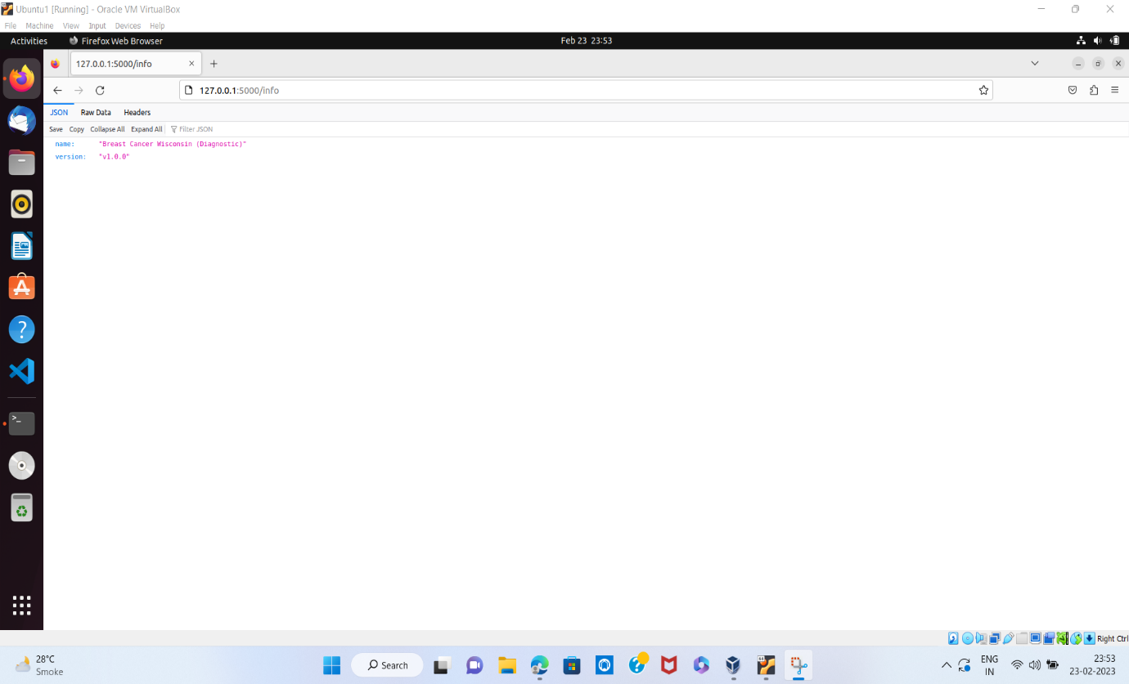

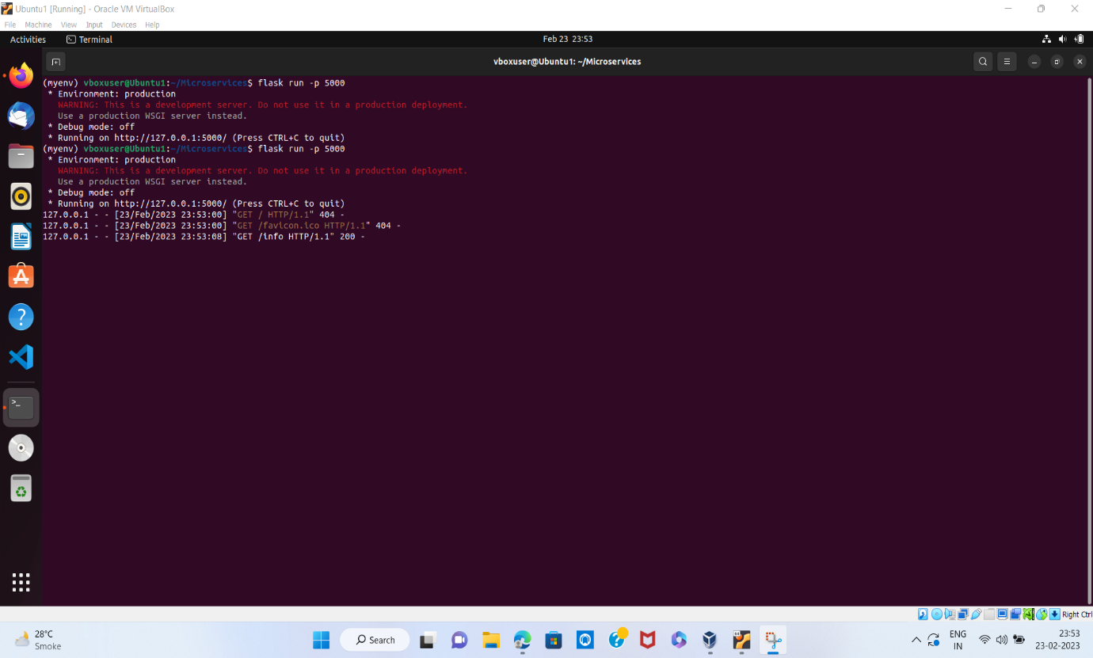

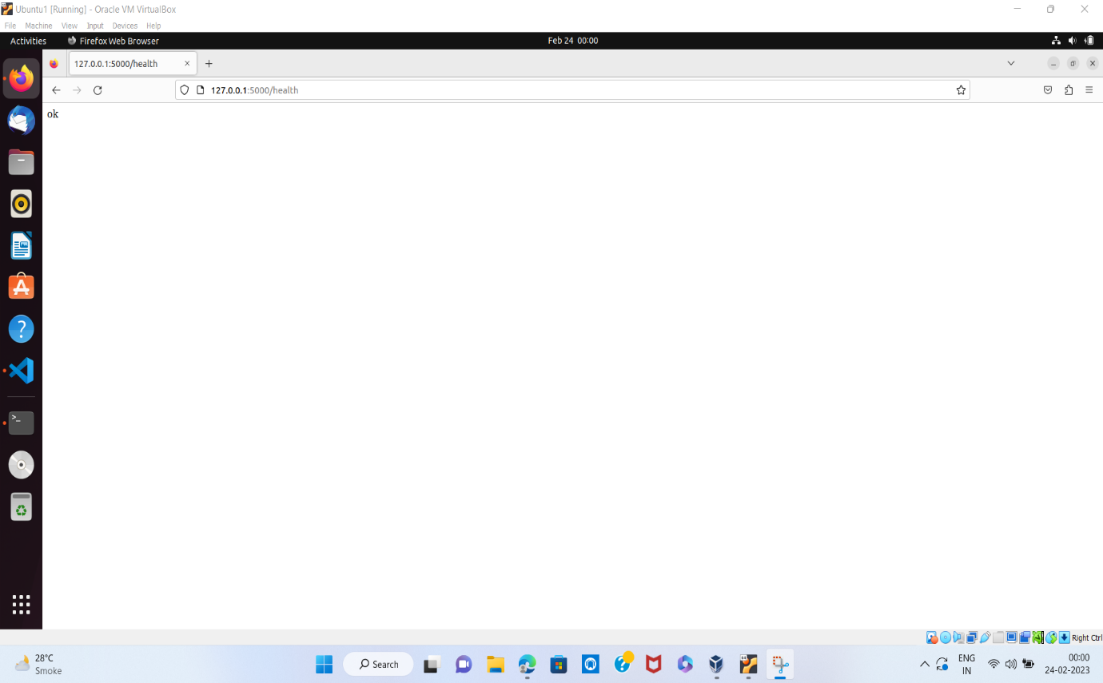

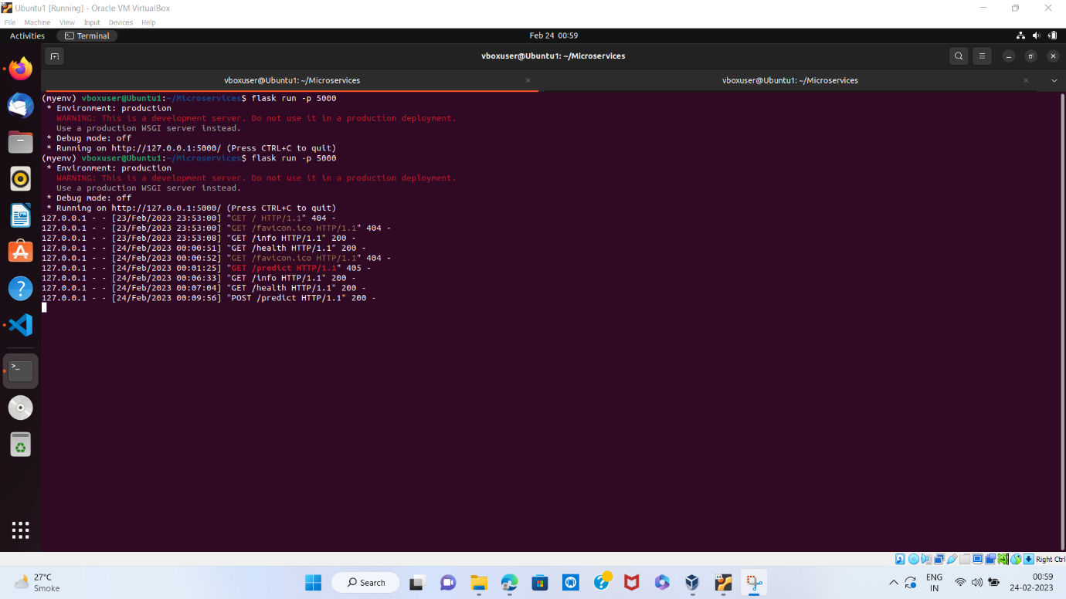

**9.Test the application and make predictions using the example calls available in the folder/tests.**

Command : curl -X GET http://localhost:5000/info

curl -X GET http://localhost:5000/health

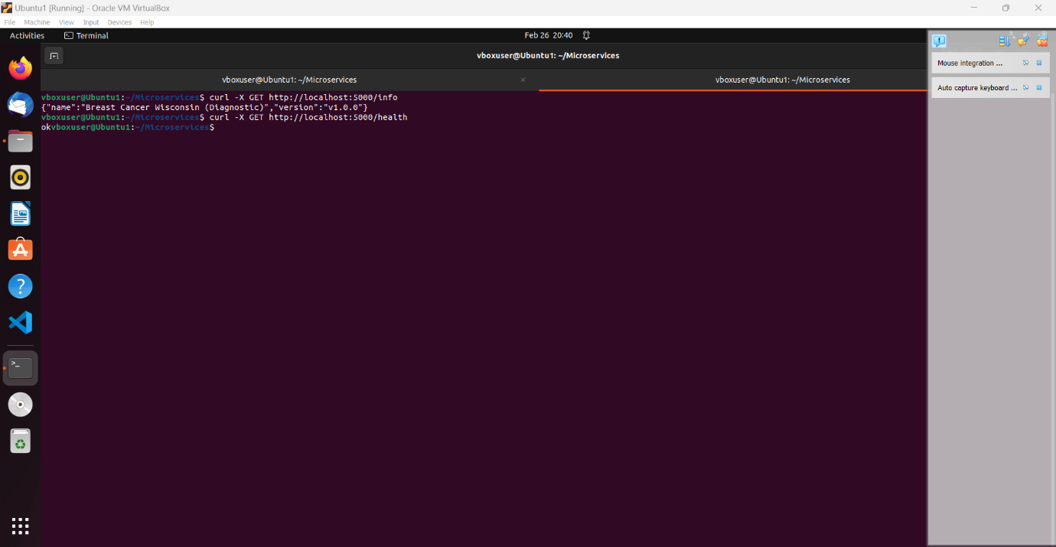

POST method predict :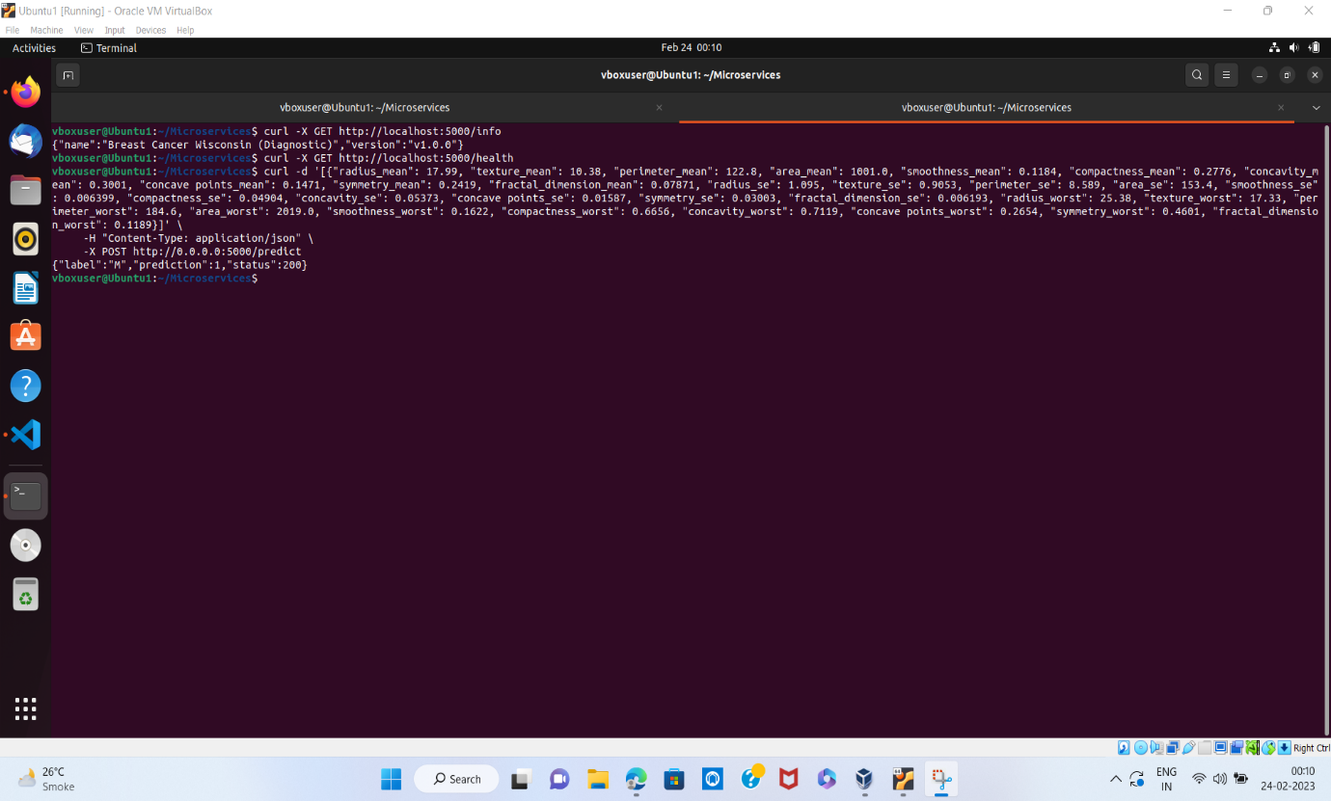

**10.Create a docker image containing everything needed to run the application.**

Docker Installation and creating a docker image

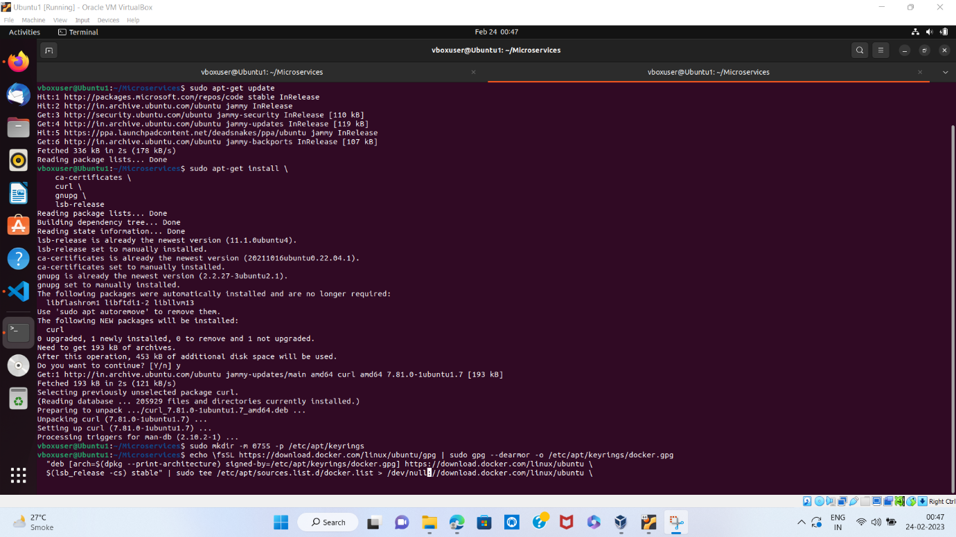

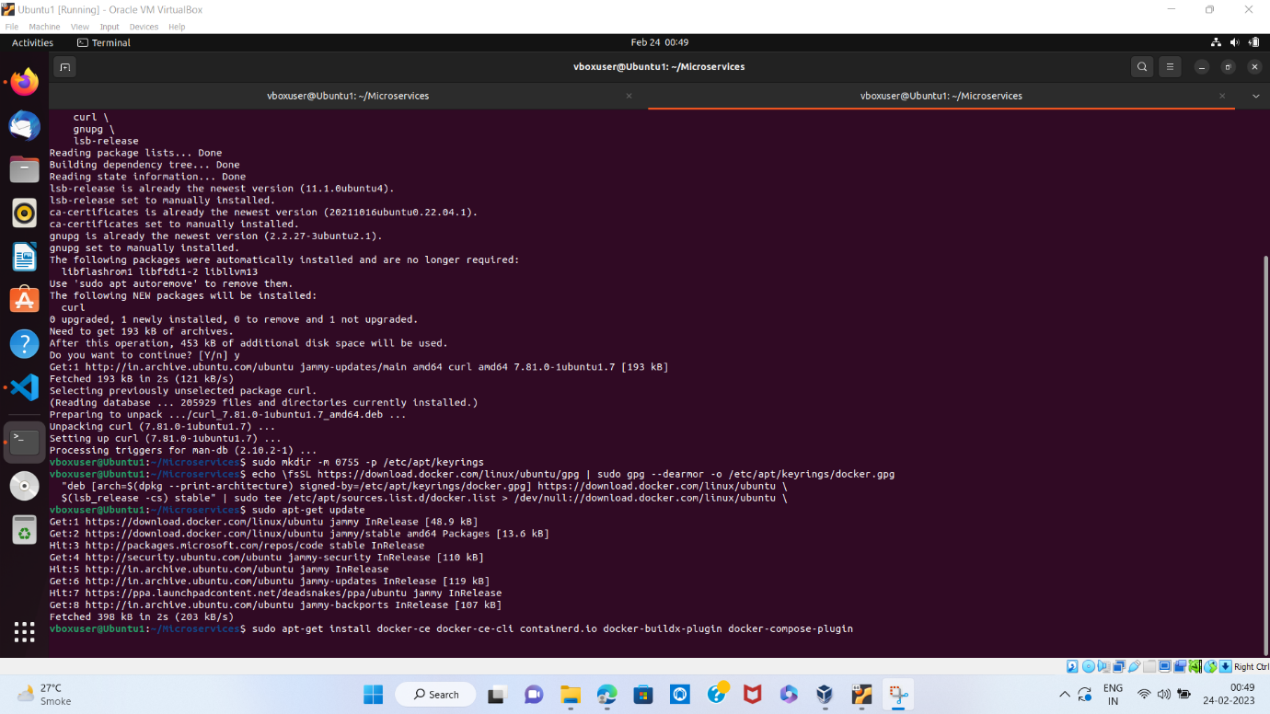

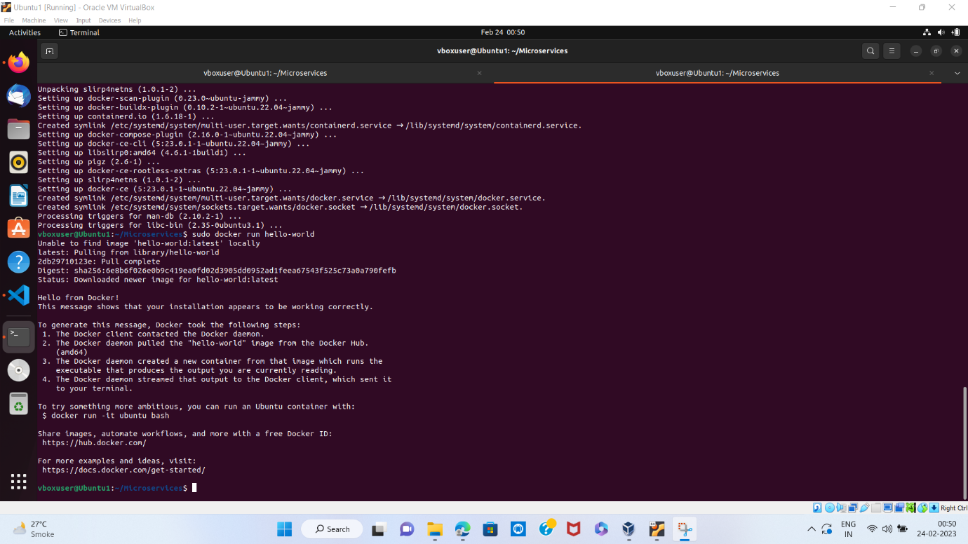

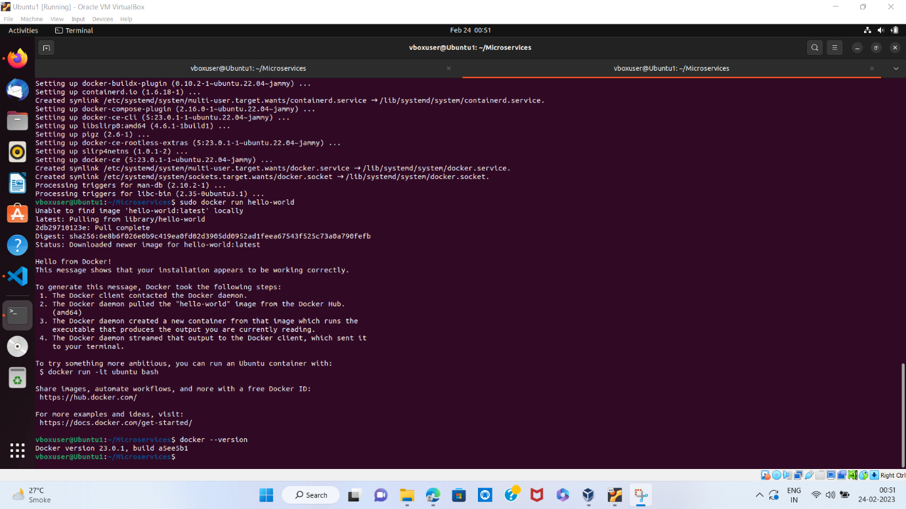

Creating a docker image

Command : docker build -t microservices:latest .

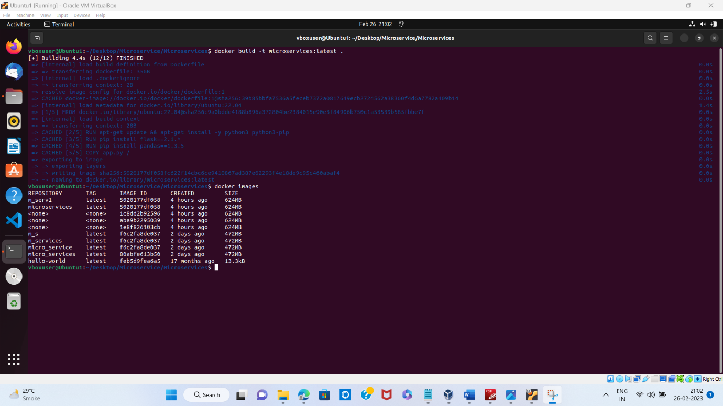

**11.Run the containerized application as a prediction service and test it locally by passing some example calls and get the prediction.**

Command : docker run -p 8000:8000 microservices:latest

